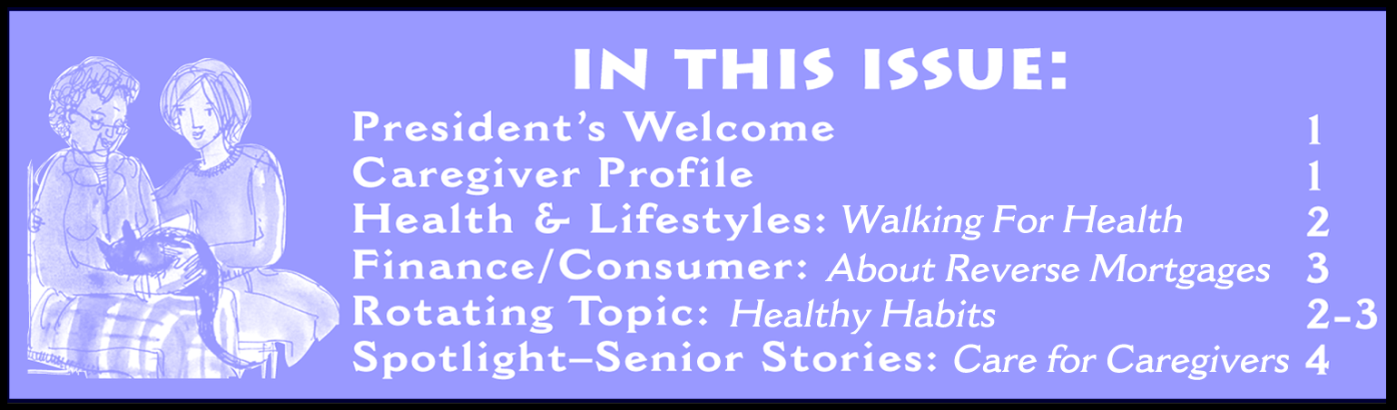

FALL 2004

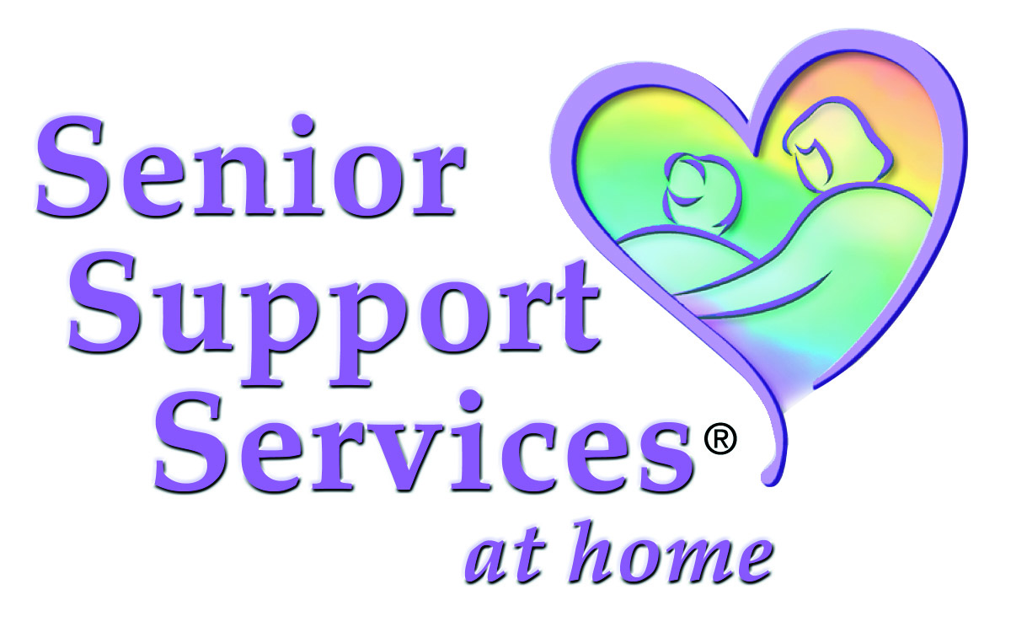


The

Senior Support

Services Newsletter

Welcome to our Fall ‘04 Newsletter.
We hope you enjoy the offerings in our latest issue.
Fall News:
Certified Companion Aide Program
We are excited to tell you about our training program, CCA. The Certified Companion Aide Program is a certification training program designed to elevate the skills and knowledge of our caregivers to a level unparalleled by other companion care companies. The purpose of the program is to create a measurable standard by which to evaluate our caregiving staff.

The program consists of approximately 10 hours of instruction presented on DVD and a companion text. Committed caregivers who pass the required testing will receive the title Certified Companion Aide, a certificate of accomplishment, and a lapel pin to identify them as such. No other companion care company has a program like this. Other companies offer minimal training for their caregivers and have no way of measuring their Cg’s skills.

Areas of study the training covers are as follows:
• Communications
• Infection Control
• Safety and Body Mechanics
• Emergency Care
• Basic Human Needs
• Understanding Aging
• Dying, Death and Hospice
• Providing Personal Care
• Promoting Independence: Rehabilitation and Restorative Care
• Observations about Medications and Technology in Home Care
• Assisting Clients with Disabilities
• Understanding Mental Health and Mental Illness
• Common Chronic and Acute Conditions
• Maintaining a Clean, Safe and Healthy Environment
• Understanding the Nutritional Needs of Clients
• Meal Planning, Shopping, Preparation, and Storage

This program is in keeping with our goal to offer our client’s the highest level of service available in our field.

Best wishes,
Norman R. Agran,
President & CEO,
Senior Support Services,
Serving Central
New Jersey

Serving Central New Jersey • 908-604-8368
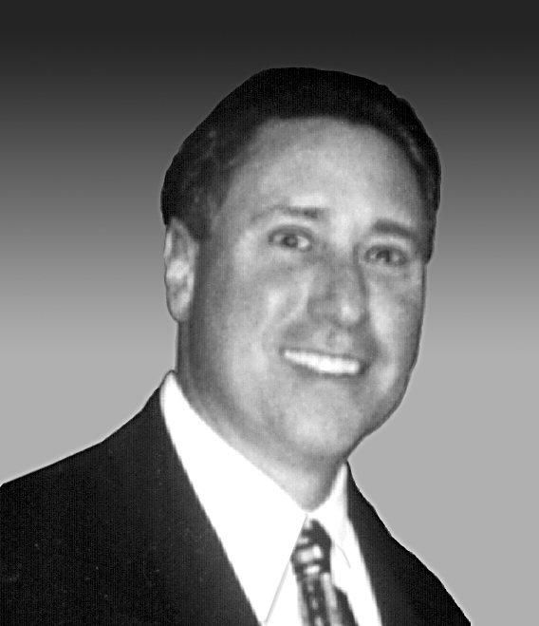
Our caregivers are totally committed, highly qualified and carefully selected individuals who are personally and thoroughly screened, bonded and insured.
Most importantly our caregivers are dependable and extraordinarily caring of others. In addition to their previous experience, our caregivers receive continuous training that includes a specialized curriculum exclusive to The Senior’s Choice.
These highly qualified and trained caregivers are ready to help you and your loved ones with a variety of
daily activities such as:
* Caring companionship
* Meal planning and preparation
* Incidental transportation
* Running errands
* Light housekeeping
* Medication reminders
* Assistance with bathing and grooming
* Assistance with bill paying
* Information and referral services
Our personalized and affordable services are available 7 days a week and can range from a few hours a day to 24 hour and live in care.
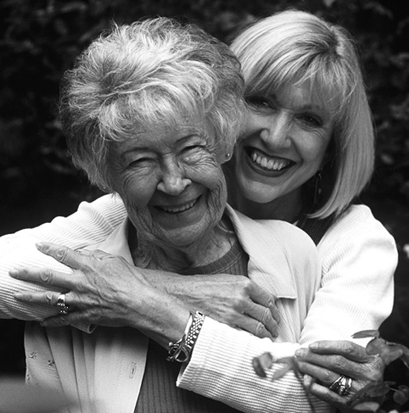




Walking may be the best fitness activity for many seniors given the relatively low physical risks and the enormous long-term health benefits.

The Foot Health Foundation of America—the education arm of the American Podiatric Medical Association (APMA)—has issued guidelines for seniors in response to the recent release of two major long-term studies confirming the beneficial effects of regular walking on a person’s overall health and well-being.

Benefits of Walking
• Controls weight, blood sugar and cholesterol levels. A brisk walk can burn up to 100 calories per mile or 300 calories per hour. Walking is the perfect complement to a sensible diet to lose weight and keep it off;
• Improves cardiovascular fitness and circulation. Walking gets the heart beating faster to transport oxygen-rich blood from the lungs to the muscles;
• Facilitates medical rehabilitation from many ailments, including heart attack;
• Generates a sense of well-being, and can relieve depression, anxiety and stress by naturally producing endorphins, the body’s natural tranquilizer.

Getting Started
The Foundation recommends the following guidelines when establishing a walking routine:

• Warm up and cool down; stretching improves circulation, decreases muscle stiffness and prevents future muscle strain.
• Choose the proper footgear; look for a shoe that is stable from side to side; well-cushioned and enables you to walk smoothly and comfortably.
• Walk on soft ground; softer ground is more foot-friendly, producing less shock than harder surfaces
• Set appropriate and realistic goals; pace yourself, choose an activity you like, increase your exercise program gradually, and pay attention to what your body, including your feet, tells you.
• Find a “walking buddy” or join a walking club in your neighborhood; this ensures both consistency and safety to your exercise routine.
For more information on walking or general foot care, please call 800-FOOTCARE or visit the APMA’s Web site at www.apma.org.

When it comes to your well-being, don’t underestimate the importance of the people closest to you. Whether it’s your partner, children or close friends, the people you count as family and friends play a role in your health. And don’t ignore the power that pets can play in your life.
“Relationships with family and friends are very direct and personal,” says Paul Takahashi, M.D., a specialist in geriatrics at Mayo Clinic, Rochester, Minn. “They’re an important part of your social support network and can provide needed emotional and spiritual support and a sense of connectedness.”
A 1999 study by Thomas Glass and colleagues from the Harvard School of Public Health indicates that connecting with people as you age might prove just as powerful as exercising.
Strong relationships with your partner or family can motivate you to take care of yourself—to eat right, exercise and get regular medical care. Your partner and family also can be an important buffer from the stresses of everyday life. And if your health isn’t good, your family might help get you the medical care you need to manage your condition more successfully.
A MacArthur Foundation study on aging points out that strong social support can promote longevity by:
Healthy Aging, continued on page 3

Walking For Health!

Healthy Habits for Healthy Aging: Nurturing Relationships
• Enabling you to get better or more prompt medical care
• Encouraging you to engage in healthy behaviors, such as walking regularly and quitting smoking
• Allowing you to receive direct expressions of affection, which in turn might increase your immunity to disease
• Providing you with practical help when needed—assistance with household chores, transportation and loans, for example
Reconnect with old friends and try meeting new ones. Creating and maintaining meaningful relationships can be difficult, but it can also be rewarding. Try some of the following:
• Call a friend you haven’t talked to in a while.

FALL 2004 NEWSLETTER PAGE 2

Whether seeking money to pay for medical treatment, finance a home improvement, buy long-term care insurance, or supplement their income, many older Americans are turning to “reverse mortgages.” They allow older consumers to convert the equity in their homes to cash while retaining home ownership.
With a “regular” mortgage, you make monthly payments to the lender. But with a reverse mortgage, you receive money from the lender and generally do not have to repay it for as long as you live in your home. In return, the lender holds some—if not most or all—of your home’s equity.
Introduced in the late 1980s, reverse mortgages can help homeowners who are “house-rich-but-cash-poor” remain in their homes and still meet their financial obligations. The proceeds of the loan are tax-free, there are no minimum income requirements, and for most reverse mortgages, the money can be used for any purpose.
But, reverse mortgages also tend to be more costly than other loans, and there have been cases of abuse by unscrupulous lenders.
If you’re considering a reverse mortgage, it’s important to understand how the loans work and what your rights and responsibilities are.
The Basics
Types of reverse mortgages:
• The federally insured Home Equity Conversion Mortgage (HECM), administered by the Department of Housing and Urban Development (HUD)
• Single-purpose reverse mortgages, usually offered by state or local government agencies for a specific reason
• Proprietary reverse mortgages, offered by banks, mortgage companies, and other private lenders and backed by the companies that develop them.
To qualify for a reverse mortgage, you must be at least 62 and have paid off all or most of your home mortgage. Income is generally not a factor, and no medical tests or medical histories are required. If you seek an HECM, you also must undergo free mortgage counseling from an independent government-approved “housing agency.” Financial institutions offering proprietary reverse mortgages may require similar counseling or homeowner education.
The amount you can borrow depends on your age, the equity in your home, the value of your home, and the interest rate. If it’s an HECM, federal law limits the maximum amount that can be paid out. You can be paid in a lump sum, in monthly advances, through a line of credit, or a combination of all three.
Reverse mortgages offer special appeal to older adults because the loan advances, which are not taxable, generally do not affect Social Security or Medicare benefits. Depending on the plan, reverse mortgages generally allow homeowners to retain title to their homes until they permanently move, sell their home, die, or reach the end of a pre-selected loan term. Generally, a move is considered permanent when the homeowner has not lived in the home for 12 consecutive months. So, for
example, a person
could live
in a nursing home
or other medical facility for up to 12
months before the reverse mortgage would be due.
Consumer Advice
Is a reverse mortgage right for you? Before you decide, consider all your options; you may qualify for other less costly credit plans. Information to help you decide is available from:
AARP
1-800-424-3410 www.aarp.org

The National Center for Home
Equity Conversion
1-651-222-6775 www.reverse.org

U.S. Department of Housing and Urban Development (HUD)
1-888-466-3487 www.hud.gov

Federal Trade Commission
Consumer Response Center
www.ftc.gov

Healthy Aging, continued from page 2
• Resolve conflicts by openly talking about past differences and striving for a new beginning.
• Make new friends with similar interests. Consider joining an organization or club.
• Continue to be a part of your family members’ or friends’ lives.
• Join a support group. This can be especially important if you live with a chronic disease or condition. For example, older people who are connected to a support group report better control of their chronic pain.
• Nurture your spiritual life. Connecting with God or a higher power—however you define those terms—can boost your health. People who pray or meditate or who have a religious affiliation appear to survive a life-threatening illness longer. And a church or other spiritual community offers a source of social support.
• Link to your wider community by volunteering. Meet other volunteers and help others at the same time.
Surrounding yourself with friends and family can do more than keep you happy. It might even keep you alive.
This is the first in a series of topics from The Mayo Clinic on tips for “Healthy Aging.” www.mayoclinic.com

About Reverse Mortgages

FALL 2004 NEWSLETTER PAGE 3


Serving Central New Jersey
908 604 8368
Health and Human Services Secretary Tommy G. Thompson today thanked the millions of Americans who care for family members with disabilities or chronic illnesses and urged them to make sure that they look after their own health as well.
“In more than 20 million homes across the country, family caregivers play a critical role in ensuring older Americans are treated with the love and compassion that they deserve, but too often caregivers put their own health on the back burner,” Thompson said.
“They need to eat right, keep active and stay healthy themselves if they want to continue to provide needed care and support to their family.”
HHS sponsored a national town hall meeting at its headquarters, calling the nation’s attention to the heroic efforts of family caregivers and the challenges confronting them. Family caregivers at the town hall offered personal testimonies about their experiences, including the positive impact that health promotion activities have had on their quality of life.
Family caregivers are a critical source of care to people with disabilities and chronic health problems. One study found that the unpaid and informal care that the family caregivers provided in 2000 was estimated at about $257 billion.
Caring for a family member with a disability or chronic condition poses significant health risks and can contribute to physical and mental health problems affecting caregivers. In one long-term care survey, sponsored by HHS, about a third of caregivers described their own health as “fair to poor.”
Other recent research findings suggest that stress associated with family caregiving can result in increased risks of infectious diseases, such as colds and flu, depressive symptoms, and chronic diseases, such as heart disease, diabetes and cancer. Family caregiving, when accompanied by emotional strain, has also been found to be an independent risk factor for mortality among older adults.
HHS is spearheading several efforts that provide support to family caregivers nationwide. Its Administration on Aging (AoA) runs the National Family Caregiver Support Program, which provides information about available services; assistance in accessing supportive services; individual counseling, support groups and caregiver training; respite care including in-home care, adult day services or short stay in a nursing home; and supplemental services, on a limited basis, to complement caregivers' efforts. The program was launched in Feb. 2001.
HHS has also worked with states to promote consumer-directed care options through the Medicaid program. This approach can provide resources to help beneficiaries remain in their homes and allows family caregivers of all ages to arrange the services they need when they want them.
For more information see the “aging” section of the HHS website at:
www. hhs.gov/aging

Care for the Caregivers

We wish to recognize the challenge for the many families we assist with caregiving with this December 2003 article from The Caregiving Resource Center (www.thoushalthonor.org)

